**FINAL TEAM NAME:** TEAM WETBLOCK

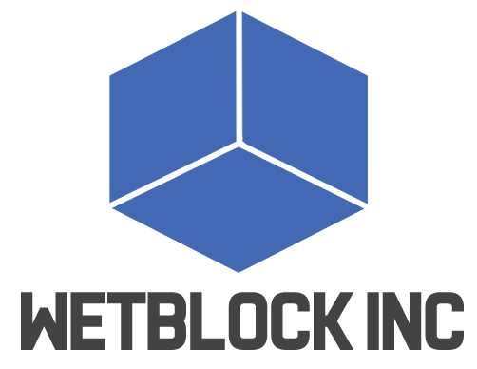

**APP NAME:** PIZZA PARTY

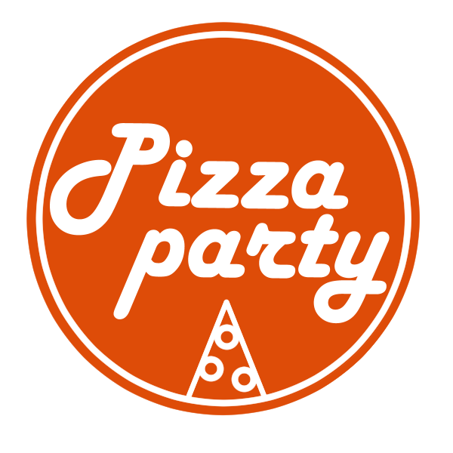

**SCREENSHOT**

